BEI TS Model
1.0 Rev history 1
2.0 Instructions 4
3.0 BEI Standard Process Model Flow Sequence 5
4.0 Features 6
5.0 Design and Rationale 8

BEI standard TestStand process model is reuse code. It does not have a part number, it is not "released", it is not officially controlled or validated separate from specific test projects (yet). It includes sequential and parallel models based on NI sequential and parallel models.

Relevant Documents
FCT SW Design Guidelines.doc
FCT Coding Guidelines.doc
Target 3 Software setup instructions.doc
NI Developers SN J13X79645.txt
FCT SW License Guidelines.doc
LabVIEW PFS2000 Users Guide.doc
restoring standard TS type versions.txt
TestStand Std NI_types.doc
Sentry Client Developers Manual.doc
DB Access VIs Manual.doc
NI TestStand Verification and Validation Best Practices
PFS Tester Link
\\ang-pfsfs01\Portal_Documents\PFS\Testlink_V2_Developers_Guide.pdf

Rev history
Rev5
- Remove Launch NextTestSW functionality
- other
Rev 4.8.5
- Launching LabVIEW message
- New local Sentry layout at StationGlobals.SentryData
Rev 4.8
- cleanup GUI and Model requests
- updated section 2 and added section 3 to documentation
- when GUI EXIT is pressed, terminate controller execution and exit GUI (don’t wait for exit gui request from controller)
- make getReqToModel.vi set RunState.Root.Parameters.Shared.LVserverGone not RunState.Root.FileGlobals.LVserverGone
- remove 1st 'Wait For TestSockets' in TestUUTs Cleanup
- improve TargetStats VIs to have step status criteria input
- fix sentry client related issues
- show VI path checking
Rev 4.7
- improve db.llb, includes a build query VI and better query forms VIs
- sort FileGlobals
- correct step reporting in Check Sentry sequence; increase font size in Select Operation vi
- added example step in template for removing skipped step result
- fixed invalid target in getSN
- improved TesterDefaultState
- added SocketDefaultState
- improved sequence comments
- added callbacks in template
- improved retry for Sentry and PFS
- in ProcessSetup, relocate RTFC after Sentry
Rev 4.6
- support PFSv4
- fixed "remove step if pass or done" feature on popup in MainSequence
- fixed operation GUI
- improved OperationCode handling, removed code using DAQmx from the model
Rev 4.5
- Clear WO when turning PFS off
- set directory to main file directory
- fix precondition on “If User is Operator, turn PFS on” in seqfileload of main file
- configure execution every PreUUT, with locks
- fix configure execution DB step DisableDatabaseLogging path
- put database info in header
- no property not found message if result status can’t be found in GUI
Rev 4.4
- Sense UUT not present to continue after PostUUT
- Add socket ID to report
- Add socket control to parallelUUTsGUI.vi
Rev 4.3
- Shared local sentry flag
- Set current directory to project directory
- in ProcessModelPostStepFailure sequence: Fail message to GUI for looping steps; skip Fail Socket Color message to GUI when looping step will retry.
- Remove logout at change user sequence
- For sequential mode (no GUI), simply set NumTestSockets = 0
- FileGlobals.UsingGUI was FileGlobals.AsSocket
Rev 4.2
- Better change user function on GUI, and hide WO on GUI if WO==””
- Better PFS library, better PFS2000, supports assembly mode
Rev 4.1
- precondition at step 'Copy PreUUT Results to MainSequence Results' in seq 'Test UUTs' to check if RunState.Root.FileGlobals.PreUUTResultList exists
- fix for callback calling callback
- modifyreportheader and footer to support html reports
- add postmain and processcleanup to template
- update ProcessSetup SW PN and Rev step
- in TestUUTS, at "Wait For Dialog Initialization", increase timeout to 20s
- add InitialInstrumentSetups seq with temperature checks
- put SW info in general message area of GUI
- GUI shows TS user if PFS is off
- in RequestToDialog.vi, pass errors back to TS
- add second execution not allowed to parallel TestUUTs
- add logging of PFS2000 transactions
- add terminate button on RTFC md5 check gui
- add pfs2000 setting for timeout in ini
- change PFS2000 TCP read to standard?
- error if step reports results in controller execution, fix: in ProcessModelPostResultListEntry, skip to end if not a socket
- retry if pfs2000 connection is closed without a response received.
- ProcessDialogRequests, set Call Requested Sequence to be new thread
- in View TestSocket Report - Current Only, add message to socket
- in socket sequence, after writing report, copy report file path to Parameter.TestSocket.ReportFilePath
- make it easy to set tester to never use PFS, with FileGlobals.requirePFSforOperators
- ! needs to be in front of SN in TestReport filename if no PFS
- normally, SN prompt should not include "press Test"
- Add example code for sensing UUT
- in sentryrequest vis, don't care about PFS state
- add seq call in seqfileload seq to run main sequence if user is operator
- add math.llb with float bit functions
- remove testerID input to PFSgui, testerID should come from pfs.txt
- reverse order of cleanup steps in CheckSentry callback
- Make ModelData.ReportOptions = Socket ReportOptions
- add postmain and processcleanup to template
Rev 4.0
- check Sentry in Process setup (before 1 time HW setups);
- add functionality to auto launch Next TestSW;
- precondition all getDialogRequest and RequestToDialog calls with RunState.Root.FileGlobals.LVserverGone; have those VIs set LVserverGone on error;
- monitor main TS execution in ParallelGUIs
- organize variables, eliminate redundant PFSloginInfo and Shared variables
- add step for detecting UUT
- add WindowPosition.vi in dialog.llb, used in GUIs
Rev 3.9
- To support TS4.1, modify module paths with “Components\NI\” to be completely relative.
- Check “isModified” property rather than “change count”, this approach recognizes saves without restarting TestStand
- Add sound?
- Sentry, RTFC, and PFS can each be enabled independently in FileGlobals. (FileGlobals.Sentry, RTFC, and noPFS)
- Move localSentry from StationGlobals to client FileGlobals (leave PFS2000 in StationGlobals to facilitate transition from PFS to PFS2000 without TWM)
- Move FileGlobals.disallowDebugPFS and disallowModifyAfterLoad from model to client:
- Remove boolean ‘asClient’
- Won’t let operator run sequence file that has ‘debug’ in the filename
- Turns off PFS if sequence file has ‘debug’ in the filename
- 3.9.3: reorganize fileglobals, use VI analyzer on all VIs
Rev 3.8
- Started rev history in BEI TS Model document
- Made all steps DynamicLoad, made all seqfile step load option: UseStepLoadOpt
- SentryRequest.vi: connected SentryClient.ini.vi to error out
- Pasted all SeqModel sequences and FileGlobals into ParModel so it does not need SeqModel. In ParModel, cleared ‘Test UUTs’ property ‘Show Entry Point When Client File Window is Active.
- BEIseqModel3.7.3.seq:
  - moved 'set product name' and 'set assembly number' from ProcessSetup to PreUUT
  - retry on error at 'Make FilePath Unique'
  - In ProcessCleanup, enable breakpoints and set for prompt on error
- TS2checkFiles.vi: set files read only (except those with 0 MD5)
- SentryClient.ini: GatewayServer= test-sentry.mn.bench.com

Instructions
For Test Developers:
Assuming PC is setup with NI TS and LV and TargetStats (see \\mn-s01\groups\ENGE\FTD\guidelines\Target 3 Software setup instructions.doc sections 3.4 and 3.6)
- From get BEIstdModel.x.zip and extract, with folder names, to C:\.
- Find the BEIstdModel directory and rename it as appropriate for your project.
- Open the BEIstdModel and the BEItemplate .seq files and save them.
- Open all.vi in modelsupport; under the File menu, ‘Save all’.
- BEItemplate-LF-V1_0.seq is a “client” (main sequence file) template that uses the BEI standard process model. Avoid modifying the process model; modify the client template as needed for your project:
- The client filename should be your test SW part number
- Consider if you should use Sentry; see Sentry Users Manual.doc and understand normal mode and local mode, follow applicable instructions in that manual.
- Consider if you should have Runtime File Control enabled; see \\Win-wds1\ftd_software\NI Dev Suite\TS addons\SWcontrolTools\SWcontrolTools.doc
- Edit steps in the ‘Benchmark Options’ and ‘Project Specific Settings’ sections in your client’s ProcessSetup callback, as appropriate
- Edit ‘Set ReportDirectory’ step in your client’s ReportOptions callback
- Edit ‘Set Connection’ step in your client’s DatabaseOptions callback
- Use the example sequences and their steps as needed, delete what you don’t need.
- The model supports PFSv4, if this is not available, install a translation service from \\Win-wds1\ftd_software\PFSv4toPFS2000 or \\Win-wds1\ftd_software\PFSv4toPFSMN
- Edit ModelSupport\PFSv4.ini Operation_Codes value as appropriate
- To help plan the locations for your project specific setup and cleanup steps, read three Note steps at the beginning of the MainSequence setup group, and the Note steps at the beginning of the main step group in ProcessSetup and ProcessCleanup.
- If you have custom StationGlobals, edit ‘SequenceFileLoad’ to add steps to create them if they are missing (supports easy tester restoration or replication).
- If your project is using the Runtime File Control functionality, run the ">SWcontrolMD5s..." tool to regenerate MD5s as needed (follow instructions at \\Win-wds1\ftd_software\NI Dev Suite\TS addons\SWcontrolTools\SWcontrolTools.doc)
- When you set up operator users in the User Manager, ensure TS login name equals PFS login name.

Operator level users:
- Log into TestStand, open client sequence, and execute TestUUTs
- When prompted, login to PFS, scan fixtureID, scan serial number
- When test is done, enter password at Acceptance Signature prompt

Debug Techs:
- Model and client errors are logged to an error log file in sequence directory.
- For report when running selected steps, use run selected steps using TestUUTs
PFS is disabled for users that have debug privileges

BEI Standard Process Model Flow Sequence
Controller (TestUUTs sequence) | Standard GUI |  | Socket
Start Standard GUI (in new thread) | Initialize, setup request queues
Call ProcessSetup | LOOP: Handle GUI buttons; show EXIT button only while no socket has Terminate button). If Controller terminates or EXIT button is hit, then exit loop and destroy queues. | LOOP: Process Model Requests; stop if queue is gone.
Initialize TestSockets (new executions) |  |  | PreUUT Loop and Options
 |  |  | LOOP: Begin UUT loop
PreUUT/ GetSN,
GUI Request, next UUT (or goto PostUUTLoop if EXIT)
LOOP: Process Dialog Requests (controller), monitor socket threads (send SocketStopped GUI Request if applicable); stop if queue is gone. |  | Set socket for next SN state | wait for continue
 | Test button sends Model Request to socket, to continue
 | Configure socket to Running state, showing button1 as Terminate |  | GUI Request, to update WO, SN, PFS
 |  | Pull WO, SN and PFS info into GUI | MainSequence Callback  GUI Request, to append messages + update progress
 |  | Append messages received  Update progress bar as requested | PostMain Callback
 |  |  | Database and Report
PostUUT with PFS
GUI Request, display status
 |  | Display socket status, show Next and Report buttons | wait for continue,
 | Report button sends Model Request to controller
Controller displays test report file | Next button sends Model Request to socket, to continue
 |  |  | Goto beginning of UUT loop
Cleanup |  |  | PostUUTLoop
Tell all Test Sockets to Stop
Wait For TestSockets
Call ProcessCleanup

GUI Requests from Socket to GUI:
SocketNextUUT (sets GUI socket cluster for GetNextUUT state)
UpdateGUIPFS
SocketWOandSN
AppendMessage (appends text to GUI message field)
SocketProgress (sets GUI socket progress bar)
GUItoFront
SocketDisplayStatus (sets GUI socket cluster to DisplayUUTstatus state)
SocketStopped (sets GUI socket cluster to Stopped state)
SocketFailIndicator

Requests to Model controller from GUI
Continue TestSocket
View TestSocket Report
Terminate TestSocket
Change User
Terminate All TestSockets
Restart TestSocket

Socket Cluster States:
 | color | Button1 | Button2
GetNextUUT | gray | not visible (Fileglobal option) | not visible
Running | blue | Terminate | not visible
DisplayUUTStatus | varies | Next | Report
Stopped | dark gray | Restart | not visible

Typical TestStand architecture is:
a standard process model with product specific client callbacks where applicable.

Understanding the process model / client concept is fundamental to understanding typical test execution flow.
stop
continue
Initialization
ProcessSetup, PreUUTLoop,
Model Options, StationOptions,
Report Options, Database Options

Get Serial Number
PreUUT
Call Test Sequence
MainSequence
Generate UUT Report
TestReport
Display UUT Results
PostUUT
Log Results to Database
LogToDatabase
Cleanup
PostUUTLoop, ProcessCleanup

A process model is a sequence that defines standard execution flow and default functionality. “Test UUTs” is a typical process model sequence. See diagram on right.

A process model sequence file contains a process model sequence and all default model callback sequences. The names in italics in the diagram are model callbacks.

A model callback is a sequence in a process model file that can be over-ridden with a corresponding sequence in a client file. This allows a product or tester specific code where applicable, without directly modifying the process model.

A client file contains product and tester specific model callbacks sequences, as applicable; these “run on” or “plug into” a process model sequence at runtime.
Batch
BEI batch model
CONTROLLER EXECUTION: SOCKET EXECUTION:
Various Options Callbacks
Initial Configure Execution
Process Setup Callback
Initialize TestSockets executions
Add sockets to batch | PreUUTloop
<Begin Batch Loop> | <UUTloop>
Wait For all TestSockets to wait??delete?? | Wait for Proceed from Controller
PreBatch callback shows GUI,
If not continue, Stop all sockets??delete??
Remove Disabled/Readd Reenabled TestSocket Threads from/to Batch
Allow TestSockets to Proceed (for each: clear request, set notifier, wait for socket)
If not continue, exit batch loop | If not continue, exit UUTloop
Wait For all TestSockets to wait | PreUUT
 | preMain SyncUp sockets
 | Main Test, PostMain,
 | Report, datalog, PostUUT
 | Wait for Proceed from Controller
re-add sockets to batch
PostBatch Callback updates GUI status
Allow TestSockets to Proceed
</batch loop> | </UUTloop>
Tell TestSockets to Stop  Set all Test Socket notifications  Wait For TestSockets  Allow TestSocket Threads to Continue  Set all Test Socket notifications  Wait For TestSockets | PostUUTloop
exit batch dialog
Process Cleanup
Modifications to BEI parallel model to add batch functionality

- Replaced NI_ParallelModelData type with NI_BatchModelData (has additional elements)
- Replaced NI_ParallelTestSocket type with NI_BatchTestSocket (has additional elements)
- Add fileglobal TestSocketPendingRequests
- Add NI batch model sequences: PreBatch, PostBatch, Notify TestSocket Threads, All TestSockets Waiting?, ProcessTestSocketRequests, WaitForTestSocket, Monitor Batch Threads, and SendControllerRequest

In client template:
- add boolean FileGlobals.BEImodelOptions.Parallel.Batch

In BEImodelOptions:
- add step to set FileGlobals.BEImodelOptions.Parallel.Batch

In TestUUTs sequence:
- insert If Then Else section, with condition FileGlobalDefaults.BEImodelOptions.Parallel.Batch
- put current top level parallel architecture into the Else section
- add top level batch architecture in the Then section, label “Batch Parallel”
Create TestSocket Request Queue
Call ProcessSetup callback
Initialize TestSockets
---- Begin Batch Loop ----
Wait For TestSockets for snyc for GetUUTSerialNumber
Call PreBatch callback (calls SN/WO GUI, includes PFS and Sentry)
Allow TestSocket Threads to Continue
Wait For TestSockets to complete UUT (test, reporting and PFS)
Call PostBatch callback (calls batch status display GUI)
Next Batch
---- End Batch Loop ----
Tell TestSockets to Stop
Call ProcessCleanup callback

In Socket sequence:
- just prior to calling PreUUT , add ‘Sync With Controller – GetUUTSerialNumber’
- just prior to ‘Goto Next Run’, add Store Results and ‘Sync With Controller -- UUTDone’

In PreUUT sequence:
- If Batch mode, skip to Wait for UUT

In PostUUT sequence:
- If Batch mode, skip display status and wait for UUT removal section
preBatchGUI.vi:
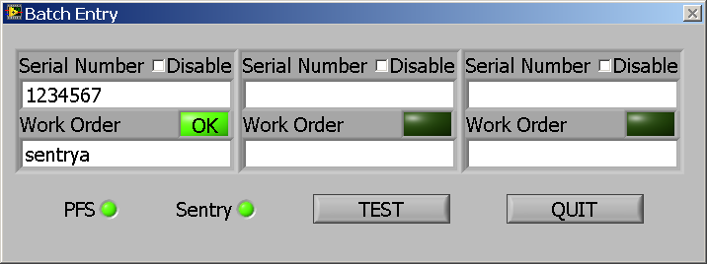

postBatchGUI

BEI Batch Model
Significant differences between GEHbatchModel.seq and NI BatchModel.seq:

- Removed sequences: Single Pass and Single Pass -- Test Socket Entry Point
- Added sequences: Check Sentry Criteria, Revoke Abort Privilege, PFStoggle, CountResultStatusTypeRecursive, SequenceFilePostStepRuntimeError
- Added Locals.SupplementalInfo container to sequences Test UUTs and Test UUTs -- Test Socket Entry Point
- In Test UUTs:
  - Add locals: SupplementalInfo, AlreadyRunning, and StationInfo
  - add steps to prevent second execution
  - add multi run loop inside UUT loop
  - move steps: Determine Batch Report File Path, why? PostBatch Callback, Tell Dialog Report Generation Is Done
  - add steps to retry writing batch report
  - add cleanup steps to aboart all VIs
  - set seq call steps to not trace
  - ignore rte on calls to Setup Report Display Settings and PreBatch; add post expression to PreBatch to !ContinueTesting on ignored error; add error display popup after Setup Report Display Settings
- In Test UUTs -- Test Socket Entry Point:
  - Locals.RTEOption is 1
  - Add Locals.SupplementalInfo
  - add steps to retry writing batch report
  - move PostUUT call to after report writing
  - ignore rte on calls to Setup Report Display Settings; add error display popup after Setup Report Display Settings

- In PreUUT, add steps to support multirun
- In TestReport, add step to modify report body
- In LogToDatabase,
  - add Parameters.SupplementalInfo
  - rather than call to external seqfile, put datalogging steps and locals here
  - seq seq properties for copy steps and local when creating over-ride callback

In Client file:

- Add sequences: StationOptions, TS Login (for aligning PFS login and TS login)
- In ProcessSetup: add RTFC, Sentry, and call to StationOptions
- In PreBatch:
  - SerialNumberDialog calls GUI VI,
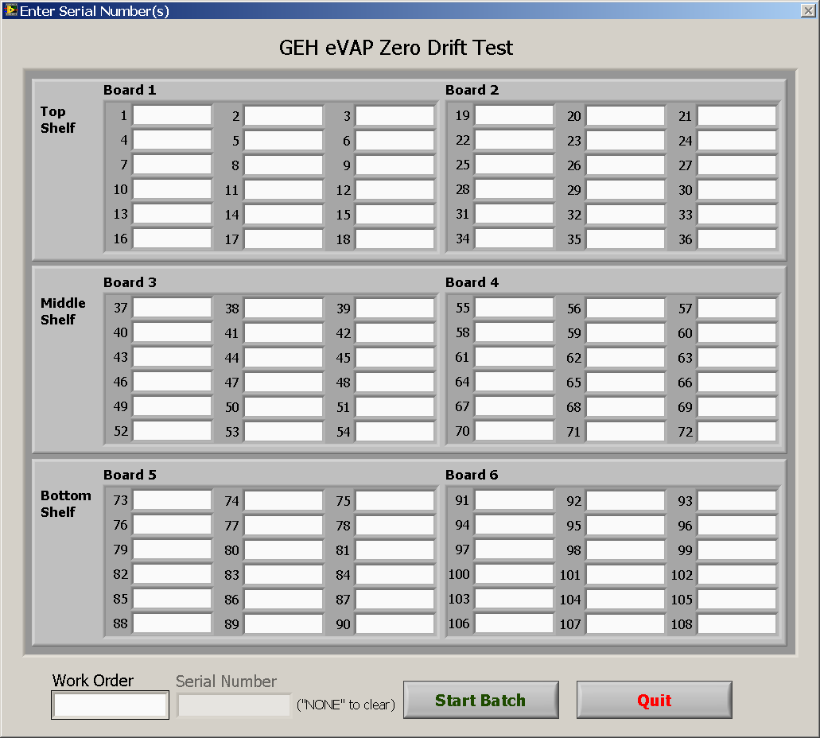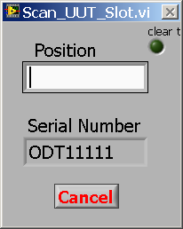
  - add “PreTest Check” section with retry loop;
  - in cleanup: If error or terminating, don't continue; manage report path and put SNs into FileGlobals; add TestSocketUUT Loop; continue if batch size is > 0
- In PreUUT: set batch report dir?
- In PostUUT: put PFS data into FileGlobals PFS arrays
- In Modify Header callback: add standard BEI data
- In PostBatch: add loop to get UUT status; add some RTFC; log results to PFS, display batch status

Features
Key features of BEIseqModel3.7:
- Gets SW part number from client sequence file filename
- Integrated PFS and PFS2000, with fail comments
- Integrated Sentry
- Enforces TS login == PFS login
- New PostMain callback for “PostUUT type” steps that you want reported to results file
- PreUUT and PostMain results merged into MainSequence results.
- Integrated Sentry calls for Tester/Fixture, SNprefix, TestSW, and ProductFW control; uses local data in StationGlobals for workorder H99999999
- Includes additional runtime SW control:
  - Disallows PFS for users with debug privileges, enables PFS for operators
  - Enforce correct TS and LV versions
  - Confirm correct path of all VIs
  - Ensure client, process model and VIs used have not been modified since loading.
  - Runtime MD5 checking for all files used
- Special settings for operator level users:
  - Breakpoints have no effect
  - goto cleanup on error (no prompt on error)
  - can terminate but can’t abort
- Standard options for reporting, database, and station settings.
- Standardized report format header and finish time in footer
- Retry once on report write error, Offer Dialog for additional retries if needed (for QSR, STE says Regulatory requires reports be written directly to the I drive)
- Supports on the fly change of operator, workorder, and operation
- Prompts for ‘Other WO or Other SN’ when PFS says SN not in WO
- Sequential model supports use as a socket in parallel model wrapper BEIparModel3.6.seq
- SeqRuntimeError callback for logging error information to a file
- Creates StationGlobals if needed
- PostUUT located to occur after report writing
- Provides PFS toggle under Configure menu
- Single pass is removed
- Runs PostUUT when it detects process model errors (abnormal flow)
- Supplemental info container to standardize reporting and data logging
- Supports data logging of supplemental info
- StationOptions callback to facilitate programmatic control
- Data logging moved before test reporting
- Multi-run functionality for verification, ‘AutoStats’ immediate stats report
- Make status banners 'floating' TS popup messages that can't be hidden or lost
- Make Dialogs modal’ or ‘floating’, so they cant be ‘lost’ behind TS or LV windows
- Display fail comment in Fail Status banner
- Insert status code into filename of non-passing reports (F, E, or T)
- Insert ! after SN into filename of non-PFS reports

Key features of the template client08-00001-00rev1.0.seq:
- Simplified option setting in MainSequence Setup group
- MainSequence Cleanup group with PFS Acceptance Prompt
- Ensures TS login == PFS login
- Includes some runtime TestSW control: DatabaseEnabled, SentryEnabled, ReportingEnabled, DebugDisallowed, Meets TestSW Criteria, Model and Client seqfile not changed since load,
- Includes example sequence for handling ProductFW control
- Includes example PeriodicVerification sequence
- Example step for maintenance schedule aid; prompts when # of cycles remaining expires

Note: the model package sequence files are in TestStand version 3.0. These can be opened and saved and used in later versions of TestStand.

Design and Rationale

\\mn-s01\groups\Coworker_Documents\Design_Group\Test_Development\Guidelines\software, coding related\FCT SW Design Guidelines.doc

High Level Architecture:
Tester Software
Test Reports
Test
Database
PFS
TestStand
LabVIEW
BEI Process Model
Test Sequence
Drivers
Code modules
Tester Hardware
GUI

Parallel Model Architecture:
The BEI Process Model is a test executive framework sequence running in TestStand; it provides reporting, database and PFS services. The BEI Parallel Process Model consists of three primary components: Controller, GUI, and one or more Sockets. This Calibration station has only one Socket. The Controller launches the GUI and the Socket.

BEI Parallel Process Model
Controller (Test UUTs)
Launch GUI
Launch test Socket
Run ProcessSetup callback
Monitor for and process Dialog Requests from GUI
Stop when Exit Dialog Request is received

GUI
Get operator inputs
Send Dialog Requests to Test UUTs
Monitor for and process Model Requests from Socket
Displays socket status information

Socket
Run UUT test loop
Update GUI by sending Model Requests
Provide reporting and data logging, and PFS
Test Reports
Test
Database
PFS

Socket Architecture

Socket
Set report settings
ReportOptions
Set database settings
DatabaseOptions
See section 3.4 below for details
MainSequence

ProcessCleanup
none
Set standard station settings
StationOptions
Continue?
PostStepRuntimeError sequence

Orange subsequences are located in the BEI standard process model

Green subsequences are typically located in the project specific sequence file

Italic items occur only when PFS is on.

Prompt for: UUT serial number or STOP
Login to PFS (if operator or workorder changes)
Confirm UUT serial number with PFS
PreUUT
PostMain
Send test result status to PFS
Display test result status to user
PostUUT
Log results to TargetStats MySQL database
Write results report
Test
Database
PFS
Prompt for test acceptance ‘signature’
Check for report and database enabled
Do Runtime File Control checks
Controller
GUI
Test Reports
Log error information to error.log file
Display error message

Operator Interface
The parallel process model GUI looks something like this:
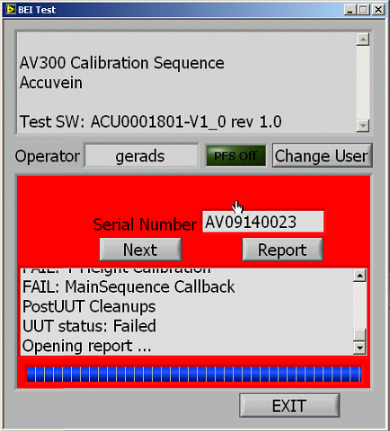
  - The bar above the bottom buttons is a progress bar.
  - Instructions are English only.
  - GUI color key: gray – enter SN, blue – testing, green – passed, red – failed, orange – error.

TestStand message popup steps are used to give instructions to the operator as appropriate, for example:
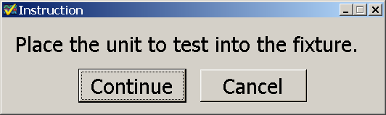

Message pop-ups include a picture where applicable.

Interface to Production Systems
The BEI standard TestStand process model includes functionality for interfacing with BEI PFS, BEI TargetStats and BEI Sentry services. Each of these functions can be enabled or disabled if necessary. BEI Sentry services are not used when PFS is off. For this tester, Sentry client functionality runs in “local mode” and obtains criteria from TestStand StationGlobals rather than from the Sentry server.

Runtime Software Control
The BEI standard TestStand process model includes file checking functionality: if PFS is on, MD5s of test software files will be checked at runtime to ensure tester software files are valid.

Test Reports
Test reporting functionality is provided by TestStand. BEI standard sequential TestStand process model provides standard report headers that include:
- Tester Description
- Tester ID
- Tester PN
- Fixture
- Test Software PN
- Test Software MD5
- PFS Station
- PFS State
- Serial Number
- Start Date
- Start Time
- Operator
- Execution Time
- Number of Results
- UUT Result

Sequential Mode Architecture:
Pre Loop
Pre UUT
Post UUT
PostLoop
Main
Test Sequence
Start
End
stop
continue

Model, changes relative to NI model
 | why
- Add engine callback ‘SequenceFileLoad’ to create station globals:  PFS, LastMO, Platform, TesterHWPN, TesterHWrev  Turn PFS on, Runs, etc | Prevent hassle to developer
- Add configuration entry point PFStoggle:  StationGlobals.PFS? "Turn PFS OFF" : "Turn PFS ON"  Enable expr: CurrentUserHasPrivilege("ControlExecFlow")  Check ‘ignore client’, ‘hide execution’, and ‘all windows’ | For easy control of PFS state for non operator
- Add SequenceRunTimeError callback; in cleanup group add step to display error banner and step to log error info to error.log | For use during tester debug
- Remove Single Pass | Because it doesn’t include some callbacks
- Make TestUUTs run interactively | So you can “run selected steps using TestUUTs”
- remove the fileglobal named boolean | It is not used
- Reorder sequences to order in which executed | More logical
- set TestUUTs Locals ContinueTesting to default to false; | For proper abnormal flow detection
- to TestUUTs Locals, add supplement info container | For standardizing supplemental info reporting
- modify callbacks for reference to supplement info: ProcessSetup, PreUUTLoop, ReportOptions, PreUUT, MainSequence, LogToDatabase, TestReport, ModifyReportHeader, PostUUT, GetReportOptions, | So supplemental info can be accessed in the callbacks
- modify steps that call those callbacks to pass reference to supplement info | So supplemental info reference gets passed.
- Make Station Options callback | To facilitate programmatic control of station settings
- In TestUUTs, following call to ModelOptions, add call to Station Options callback | To facilitate programmatic control of station settings
- Following call PreUUT step, Add:  - Message Popup step: “TS login != PFS login”  Precondition:  StationGlobals.PFS && (StationGlobals.TS.CurrentUser.LoginName != Locals.SupplementalInfo.PFSloginData.Co_worker_Number )  Post Action: Terminate  - a step to terminate if previous step errored: Precondition:  RunState.PreviousStep.Result.Status == "Error"  - a step to set report operator name:  RunState.Root.Locals.StationInfo.LoginName = StationGlobals.TS.CurrentUser.LoginName | So name in report is the same as name in PFS.
- After ‘Goto End of UUT Loop’ step, Add:  when PFS true, Locals.RTEOption = 1 | so operator wont be prompted on error
- Add structure for multiple runs of a UUT:  Add stationglobal: Runs  popup message when PFS and Runs>1; for PFSoff or 1 run  Add label ‘NextRun’ before send model state message identified.  Add 3 steps before call to PostUUT:  Goto Next Run if Runs >1; decrement Runs  End of Runs Label | Facilitates verification and validation
- After ‘determine report file path’ step, add step to delete 0k report file; ignore error; | Prevent clutter in report directory
- Following call to TestReport, add step to make uniquefilename | So no existing report gets overwritten, necessary to support changes to filename by TestReport
- Move call to PostUUT to right before Handle Termination | So PFS does not get a Pass before report is written.
- Move call to LogToDatabase right before Call to TestReport | Database is less likely to error
- Set ‘write UUT report’ steps to ignore error and not fail sequence;  following this step, add if structure conditional on previous step status is error;  add step to try ‘determine report file path’ again,  add step message conditional on previous step status is error, prompt for retry or fail  (similar modification for on the fly UUT report steps) | So test is not wasted due to temporary network glitch
- in ‘Handle Termination’ step, add Post Expression:  Locals.ContinueTesting = (Step.Result.ButtonHit==1) | For proper abnormal flow detection
- create ‘AbnormalFlowCleanup’ steps in TestUUTs Cleanup group  propagate error if appropriate  call PostUUT  Precondition: RunState.Root.Locals.ContinueTesting | if continueTesting is true, model error must have occurred and steps were skipped, report as fail  For reporting station and operator process errors to PFS for accurate station performance tracking

Other
 | why
- Add sequence ‘ TS Login’ | To support dynamic user change
- Add trim whitespace sequence | Utility

Model Callbacks, changes relative to NI model
 | why
- In ProcessSetup:  Add parameter: supplemental info  Enable PFS for operator  Disable PFS for interactive execution  Get SW# and rev from filename; prompt user to confirm  Set initial PFS operation and assembly  Skipped step as example for fixtureID query and confirm | Avoid duplication of data  To simplify maintenance
- In PreUUTLoop: Add parameter: supplemental info
- In PreUUT:
remove local: SerialNumber;
Add parameter: supplemental info
If operator level user, turn on PFS
add note: PreUUT should be for login and SN check steps.
Other tester setup steps that need to be run for every unit should be placed in your Main Sequence setup group
add steps for PFS login,
add call to TSlogin, precondition PFSuser != TSuser
message popup if still PFSuser != TSuser, generate error
Else set report user name RunState.Root.Locals.StationInfo.LoginName
Prompt for SN, MO, operation
Confirm SN with PFS, if enabled
If PFS is off and Runs>0, prompt for how many times to run UUT, default to Runs
- MainSequence: Add parameter: supplemental info
- Log to database: Add parameter: supplemental info
- Test Report: Add parameter: supplemental info;  step to modify body to remove excess recursive status text;  add steps to indicate status in filename of nonpassing UUTs;  put ! after SN in filename if PFS is off | Cleaner report  Make reports easier to identify
- Modify Report Header: Add parameter: supplemental info  Provide steps for standard BEI report header | Standardize header format
- Modify Report Footer: add end time | Why not
- In PostUUT, add local: FailComment  Add steps to set failcomment,  Steps for log results ToPFS,  Steps for display banner using ‘floating’ message popups | Allows better PFS reports  Prevents hidden dialog window
- getReportOption: Add parameter: supplemental info
- In ReportOptions: Add parameter: supplemental info  add steps for default settings and skipped steps for others  steps for optional steps;  add skipped steps for reading fixtureID;  enable reporting if PFS is on | Standardizes reporting
- In DatabaseOptions: add steps for default settings and skipped steps for optional steps | Standardized
- In LogToDatabase: Add parameter: supplemental info  Replace call to other sequence with contents of that sequence | So database has same information as report does

Client Template, clientTemplate 08-00000-00 rev1.0.seq
 | why
- In Main Setup Group:  Steps to enable reporting and database if PFS is on  integrate dynamic PFS station change (reporting, database)  goto for skipping over option steps if seqfile is root seqfile | Easy to report fixture count here  Provides flexibility  Prevents error if run w/o model
- Provide example test structure: subsequences for tests, test names include req section #;  Provide example of looping test  Provide example of message w progress bar during wait  Provide step that fails 10% of the time | Provides signs of progress  For simulation
- In Main Cleanup group:  If PFS is on:  Get acceptance ‘signature’ | For accountability  For quality
- Add SequenceFilePostStepRuntimeError like in the model file | For use during tester debug

